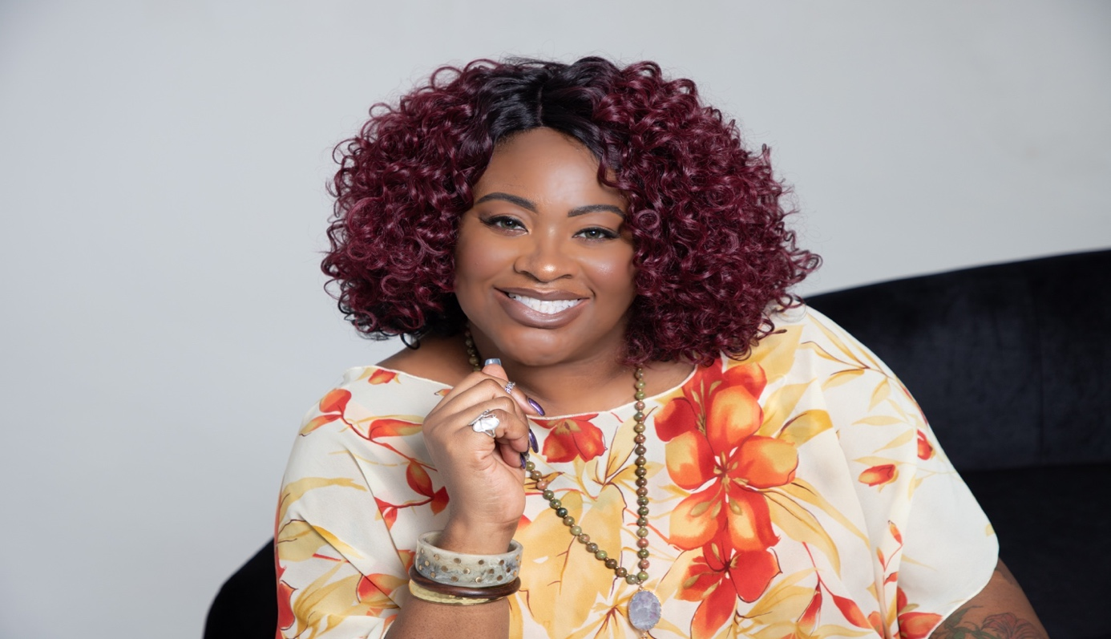
Head Shot
Bio
Latonia is the founder of Recovering Your Soul, a unique business that provides a safe space for those looking to reclaim their personal power and transform their life. As a mother, speaker, author, disabled veteran, survivor, and trauma-informed Wellness Coach, Latonia knows firsthand the importance of healing from sexual trauma. Latonia uses compassion, empathy, love, and other tools and resources to help other survivors find their way back to their authentic selves and learn how to thrive. Latonia knows survivors require a unique path to healing and overall well-being.

Contact

Phone:470-507-1735
Fax: 800-569-1856
Link tree: https://linktr.ee/recoveringyoursoul

